



Basics of Neural Network & Deep Learning Lab ENCA354

LAB FILE

SUBMITTED BY; SUBMITTED TO:
Mr. Anoja Mishra

INDEX

SR.  NO. | EXPERIMENTS | PAGE NO. | TEACHER SIGN
01.
02.
03.
04.
05.
06.

EXPERIMENT-1

Neural Network using TensorFlow (Low-Level API)

CODE:

import tensorflow.compat.v1 as tf
tf.disable_v2_behavior()

import numpy as np

X_data = np.array([[0,0],
[0,1],
[1,0],
[1,1]], dtype=np.float32)

Y_data = np.array([[0],
[1],
[1],
[0]], dtype=np.float32)

X = tf.placeholder(tf.float32, shape=[None, 2], name="X")
Y = tf.placeholder(tf.float32, shape=[None, 1], name="Y")

W1 = tf.Variable(tf.random_normal([2,4]), name="W1")
b1 = tf.Variable(tf.zeros([4]), name="b1")

W2 = tf.Variable(tf.random_normal([4,1]), name="W2")
b2 = tf.Variable(tf.zeros([1]), name="b2")

hidden = tf.nn.sigmoid(tf.matmul(X, W1) + b1)

output = tf.nn.sigmoid(tf.matmul(hidden, W2) + b2)

loss = tf.reduce_mean(tf.square(Y - output))

train = tf.train.GradientDescentOptimizer(0.1).minimize(loss)

with tf.Session() as sess:
sess.run(tf.global_variables_initializer())

for epoch in range(5000):
sess.run(train, feed_dict={X: X_data, Y: Y_data})

if epoch % 500 == 0:
l = sess.run(loss, feed_dict={X: X_data, Y: Y_data})
print("Epoch:", epoch, "Loss:", l)

result = sess.run(output, feed_dict={X: X_data})
print("\nPredicted Output:\n", result)

OUTPUT:

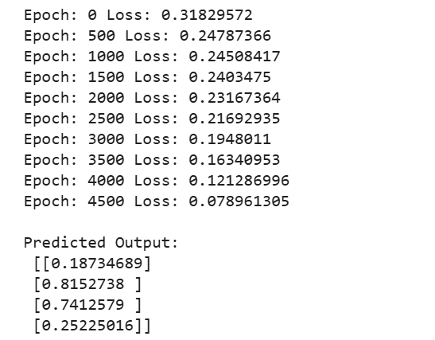

EXPERIMENT-2

Neural Network using Basic Python (From Scratch)

CODE:

import numpy as np

X = np.array([[0,0],

[0,1],

[1,0],

[1,1]])

Y = np.array([[0],

[1],

[1],

[0]])

np.random.seed(42)

input_neurons = 2

hidden_neurons = 4

output_neurons = 1

learning_rate = 0.1

epochs = 10000

W1 = np.random.randn(input_neurons, hidden_neurons)

b1 = np.zeros((1, hidden_neurons))

W2 = np.random.randn(hidden_neurons, output_neurons)

b2 = np.zeros((1, output_neurons))

def sigmoid(x):

return 1 / (1 + np.exp(-x))

def sigmoid_derivative(x):

return x * (1 - x)

for epoch in range(epochs):

hidden_input = np.dot(X, W1) + b1

hidden_output = sigmoid(hidden_input)

final_input = np.dot(hidden_output, W2) + b2

predicted_output = sigmoid(final_input)

loss = np.mean((Y - predicted_output) ** 2)

error = Y - predicted_output

d_output = error * sigmoid_derivative(predicted_output)

hidden_error = d_output.dot(W2.T)

d_hidden = hidden_error * sigmoid_derivative(hidden_output)

W2 += hidden_output.T.dot(d_output) * learning_rate

b2 += np.sum(d_output, axis=0, keepdims=True) * learning_rate

W1 += X.T.dot(d_hidden) * learning_rate

b1 += np.sum(d_hidden, axis=0, keepdims=True) * learning_rate

if epoch % 1000 == 0:

print("Epoch:", epoch, "Loss:", loss)

print("\nPredicted Output:")

print(predicted_output)

OUTPUT:

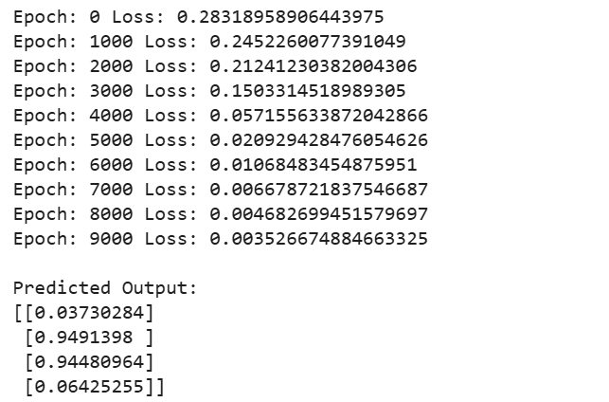

EXPERIMENT-3

Neural Network using Keras

CODE:

import tensorflow as tf
tf.compat.v1.enable_eager_execution()

import numpy as np
import matplotlib.pyplot as plt
from tensorflow.keras.models import Sequential
from tensorflow.keras.layers import Dense, Input

X = np.array([
[5.1,3.5,1.4,0.2],
[4.9,3.0,1.4,0.2],
[6.2,3.4,5.4,2.3],
[5.9,3.0,5.1,1.8],
[5.5,2.3,4.0,1.3],
[6.5,2.8,4.6,1.5]
], dtype=np.float32)

Y = np.array([
[1,0,0],
[1,0,0],
[0,0,1],
[0,0,1],
[0,1,0],
[0,1,0]
], dtype=np.float32)

model = Sequential([
Input(shape=(4,)),
Dense(10, activation='relu'),
Dense(8, activation='relu'),
Dense(3, activation='softmax')
])

model.compile(
optimizer='adam',
loss='categorical_crossentropy',
metrics=['accuracy']
)

history = model.fit(
X, Y,
epochs=50,
batch_size=2,
verbose=1
)

loss, accuracy = model.evaluate(X, Y)

print("Accuracy:", accuracy)
print("Loss:", loss)

plt.plot(history.history['accuracy'])
plt.title("Accuracy Graph")
plt.xlabel("Epoch")
plt.ylabel("Accuracy")
plt.show()

plt.plot(history.history['loss'])
plt.title("Loss Graph")
plt.xlabel("Epoch")
plt.ylabel("Loss")
plt.show()

OUTPUT:

Accuracy: 0.6666666865348816
Loss: 0.7614119052886963
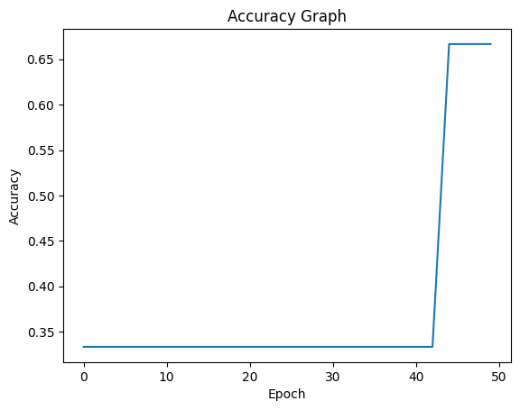
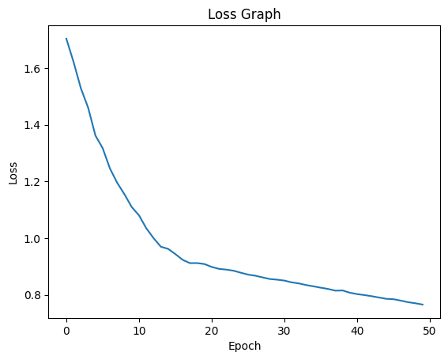

EXPERIMENT-4

Agriculture Price Prediction (Regression Problem)

CODE:-

import pandas as pd
import numpy as np
import tensorflow as tf
from tensorflow.keras.models import Sequential
from tensorflow.keras.layers import Dense
from sklearn.model_selection import train_test_split
from sklearn.preprocessing import StandardScaler
from sklearn.metrics import mean_squared_error, r2_score

url = "https://raw.githubusercontent.com/selva86/datasets/master/BostonHousing.csv"
data = pd.read_csv(url)

X = data.drop("medv", axis=1)
y = data["medv"]

X_train, X_test, y_train, y_test = train_test_split(
X, y, test_size=0.2, random_state=42
)

scaler = StandardScaler()
X_train = scaler.fit_transform(X_train)
X_test = scaler.transform(X_test)

model = Sequential([
Dense(64, activation='relu', input_shape=(X_train.shape[1],)),
Dense(32, activation='relu'),
Dense(1)
])

model.compile(optimizer='adam', loss='mse')

model.fit(X_train, y_train, epochs=100, batch_size=16, verbose=1)

y_pred = model.predict(X_test)

mse = mean_squared_error(y_test, y_pred)
r2 = r2_score(y_test, y_pred)

print("Mean Squared Error:", mse)
print("R2 Score:", r2)

OUTPUT:

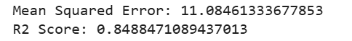

EXPERIMENT-5

MNIST Digit Classification using ANN

CODE:

import tensorflow as tf

from tensorflow.keras.models import Sequential

from tensorflow.keras.layers import Dense, Flatten

from sklearn.metrics import confusion_matrix

import numpy as np

(X_train, y_train), (X_test, y_test) = tf.keras.datasets.mnist.load_data()

X_train = X_train / 255.0

X_test = X_test / 255.0

model = Sequential([

Flatten(input_shape=(28,28)),

Dense(128, activation='relu'),

Dense(64, activation='relu'),

Dense(10, activation='softmax')

])

model.compile(

optimizer='adam',

loss='sparse_categorical_crossentropy',

metrics=['accuracy']

)

model.fit(X_train, y_train, epochs=5, batch_size=32, verbose=1)

loss, accuracy = model.evaluate(X_test, y_test)

print("Test Accuracy:", accuracy)

y_pred = model.predict(X_test)

y_pred_classes = np.argmax(y_pred, axis=1)

cm = confusion_matrix(y_test, y_pred_classes)

print("Confusion Matrix:")

print(cm)

OUTPUT:

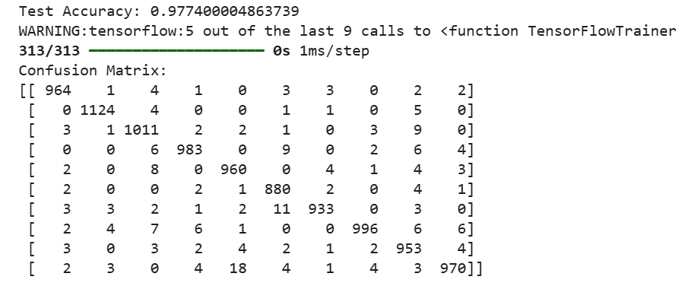

Plant Disease Detection using CNN

  - Use plant leaf dataset (e.g., from Kaggle)
  - Multi-class classification of diseases
  - Save basic prediction model

